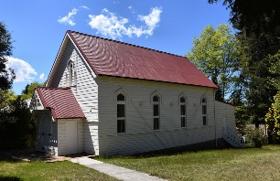

ABN 15 262 781 761

**Parish of the Upper Blue Mountains Presbyterian Church**

Please return to BANC, Gardiner Cres, Blackheath, NSW 2785

T: 02 4787 7770 / E: community@banc.org.au / W: [banc.org.au](mailto:peter.karsten@bancnsw.org.au)

**HALL HIRE BOOKING FORM FOR PRESBYTERIAN CHURCH HALL**

**First Name:** _________________________________________________________

**Last Name:** _________________________________________________________

**Company Name:** ____________________________________________________

**Address:** ___________________________________________________________

**Suburb:** ____________________________________________________________

**State & Postcode:** ___________________________________________________

**Mobile/Landline Number:** _____________________________________________

**Email Address:** ______________________________________________________

**Name of Function:** ___________________________________________________

**Description of Function:** ______________________________________________

**Date of Function** *(One-Off Event)***:** _________________________________________

**Time: From:** _____________________ **am/pm to** ____________________ **am/pm**

**Start Date of function** *(Multiple Day Event)***:** __________________________________

**End Date of Function** *(Multiple Day Event)***:** __________________________________

**If on the same day of week please indicate:**

¨ **Mon –** ¨ **Tue –** ¨ **Wed –** ¨ **Thu –** ¨ **Fri –** ¨ **Sat -** ¨ **Sun**

**Time: From:** _____________________ **am/pm to** ____________________ **am/pm**

**How Many Hours Do You Require For Function:**__________________________

**I confirm a COVID-19 safety plan is in place for my activity/function and that the plan will be available on site for inspection.**

**YES: _____ NO: _____**

**Please Note:**

There is to be no alcohol on the premises/grounds as per church requirements.